

OUM Content Management System (CMS)
User Manual (for System Admin)

February 2009

INDEX
Introduction 3
1. The Domain Selection Page 3
2. The Login Page 4
3. CMS Administrator Menu 6
4. CMS Setting 8
4.1. View Codes 8
4.1.1. Viewing Code 9
4.1.2. Updating Code 10
4.1.3. Deleting Code 10
5. Site Configuration 11
5.1. Site Management 11
5.1.1. Updating Page Setting 12
5.1.2. Updating Server Setting 12
5.1.3. Updating Menu & Display 12
5.2. Domain Management 13
5.2.1. Editing domain properties 14
5.2.2. Deleting a Domain 15
6. User Manager 17
6.1. Register user 18
6.2. View User 19
7. Content Manager 20
7.1 Module Manager 20
7.2. Category Manager 21
7.3. Article Manager 21
8. Media Manager 22
8.1. Banner 22
8.1.1. Adding New Banner 22
8.1.2. Editing Banner 24
8.1.3. Deleting Banner 25
8.1.4. Activate/Deactivate Banner Publishing 25
8.2. Category 26
8.2.1. Adding New Category 26
8.2.2. Editing Folders 27
8.2.3. Deleting Folders 28
8.3. File/Document 28
8.3.1. Adding New File/Document 29
8.32. Viewing File/Document in folders 30
8.3.3. Deleting File Document from folders 30
8.4. Gallery 31
8.4.1. Uploading Image 32
8.4.2. Editing Gallery folder 34
8.4.3. Deleting Gallery folder 35
8.4.4. Image Preview 36
9. Language & Translation 37
9.1. Language Config 37
9.1.1. Adding New Language 37
9.1.2. Editing Language 38
9.1.3. Deleting Language 39
9.1.4. Activating/Disabling Language 40
9.2. Translation 40
9.2.1. Translate Category 40
9.2.2. Translate Content 42
10. Logout 44
10.1. Auto Logout 44

Introduction

This manual has been created as a guide to the OUM portal system’s administrator (admin), providing step-by-step guidance of user administration and other system monitoring purposes. A portal basically contains numerous multimedia files such as codes, text, graphics and other elements which forms the whole OUM portal itself. Being a dynamic portal, most of these element requires frequent update and changes where necessary. By utilizing this guide, admin will find it easy to adjust and manipulate the portal’s content.

Each part of the portal content has been designed with a user-friendly icons and textual explanation to brief admin on the operations being done to the portal outlook. By analyzing the flow and understanding the roles of each components, admin can customize the portal as required by the management team from time to time. Therefore fulfilling the necessity for flexible and easy-to-manage portal, delivering the expected end-result and serving the portal users with a specific target and objectives.

1. The Domain Selection Page

This initial selection page is for admin to access individual sub-domain in the system. The page lists the available and active domain for selection. Click on the domain name to begin user access.

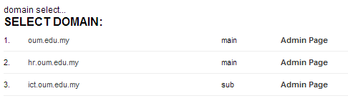

2. The Login Page

Click on the Admin Page link. This will open the login interface page (This option is only available for Administrators).

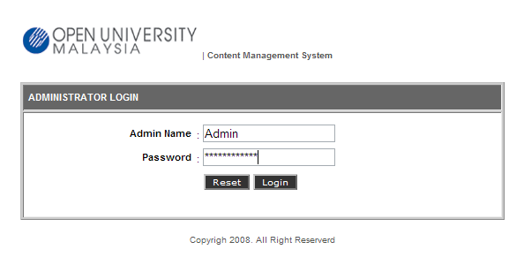

Log on to the Admin Page by typing in Admin Name and Password and click Login button. To remove these entries, just click Reset button. The field will be blank and admin now can re-enter the correct entries.

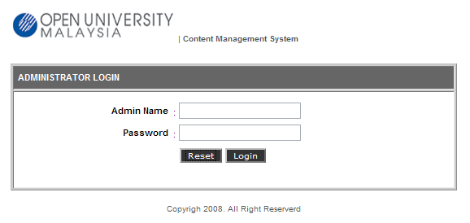

A pop-up window will appear if the entries are incorrect or the user did not have the access to the Admin page. Please contact System Administrator to gain access to this page. Click OK and user will be brought back to the Login Page.

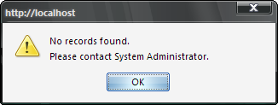

After a successful login, the user will be brought to the Content Management System (CMS) page. From here, the administration operations were categorized into different sections represented by the icons. Click on the icon text to access the content page.

3. CMS Administrator Menu

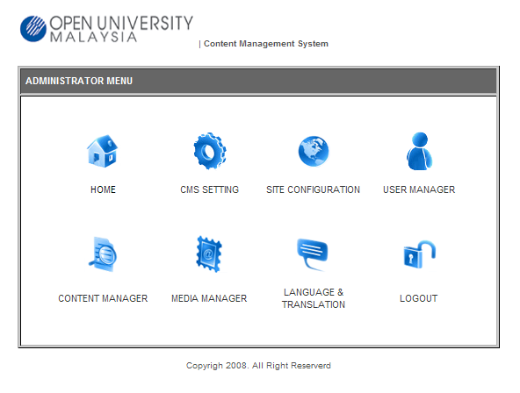

These icons were also a set of “shortcut” to the numerous sections in the CMS Administrator page, such as:

- CMS Setting – to edit settings of the CMS portal.
- Site Configuration – to edit configuration of the portal.
- User Manager – to manage and regulate user access level.
- Content Manager – to manage the setting of portal content.
- Media Manager – handles media files used in the website.
- Language & Translation – textual content translation tool
- Logout – log the current user out from the CMS portal.

The content of the CMS Administrator page are simplified in the menu as below:

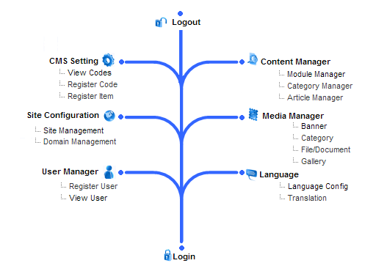

Basically, all the operations can be accessed by clicking on the operation menu located at the left side of the CMS page (Menu Area). The content/item of each operations will be displayed in the Display Area (indicated with blue boxes as below).

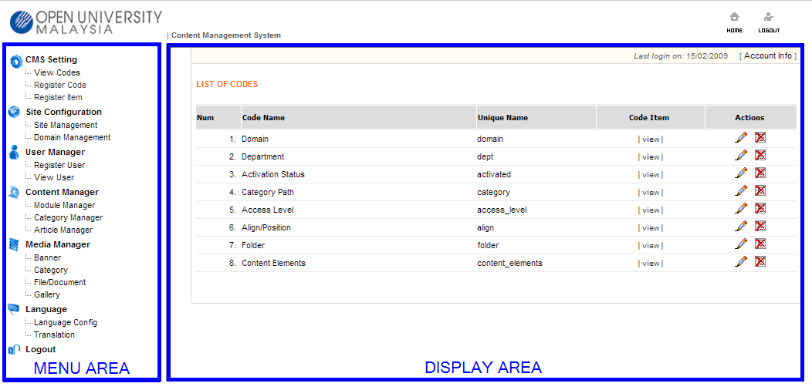

4. CMS Setting

From this page, user can perform 3 types of operations:

i. View Codes
ii. Register Code
iii. Register Item

4.1. View Codes

This operation allow the user to view and edit the list of the codes for the webpage. Items displayed in the list are the Code Name, Unique Name, Code Item (Preview) and Actions (Edit & Delete). Clicking on [view] will display the items contained inside the selected code.

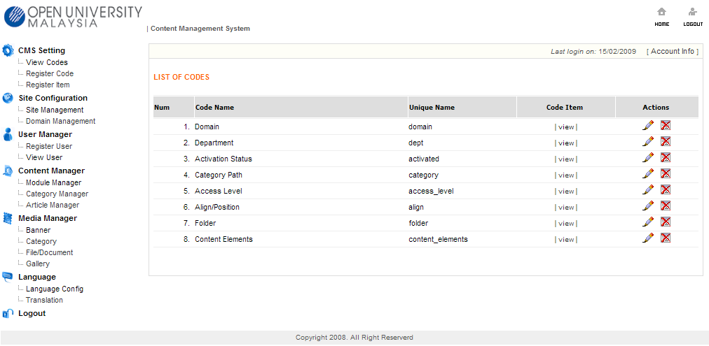

Edit - click this button to update the code.

Delete - click this button to delete the code.

4.1.1. Viewing Code

- To view the items under the selected code, click on [view] text in the Code Item column.
- The display area will show the List of Item Code, listing the items under the selected Code Name.

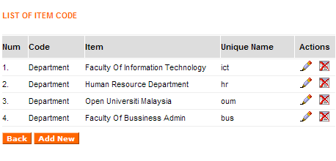

- From this section, admin can select any item and edit its properties. Click on the Edit icon and the display screen will show the details of the code, which can be changed accordingly.

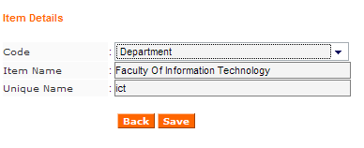

4.1.2. Updating Code

- To update a code , click on the Edit icon and the display screen will show the details of the code, which can be changed accordingly.
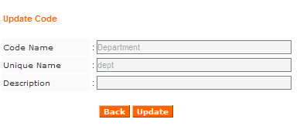
- At this point, the fields are just for viewing purpose. To update, click on Update and the details can be updated accordingly.
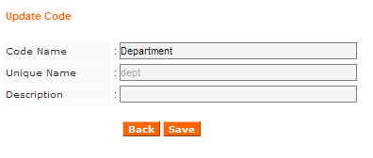
- Click Save to store the changes.

4.1.3. Deleting Code

- To delete a code, from the List of Codes page, click on the Delete icon under the Actions column.
- A pop-up window will appear to confirm the code deletion. Click OK to proceed.

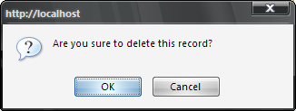

- The code will be deleted from the List of Codes page.

5. Site Configuration

Among the operations under Site Configuration are Site Management & Domain Management. The next section will explain about these operations.

5.1. Site Management

Site Management allows the admin to edit Page Setting, Server Setting and also to adjust the properties of Menu & Display.

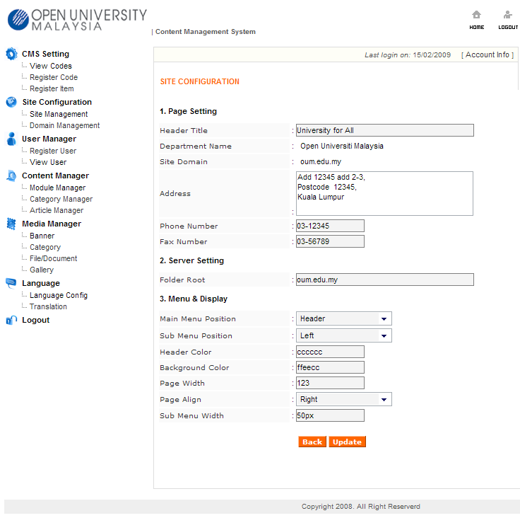

5.1.1. Updating Page Setting

- To update the Page Setting, click on Site Management.
- The editable details are Header Title, Address, Phone and Fax Number.
- Fill-in the updated details in the respective fields.
- After changes has been done, click Update to store the changes.

5.1.2. Updating Server Setting

- To update the Server Setting, click on Site Management.
- The editable details are Folder Root. Always ensure that this details are entered according to the physical domain which has been set in the server.
- Fill-in the updated details in the respective fields.
- After changes has been done, click Update to store the changes.

5.1.3. Updating Menu & Display

- To update the Menu & Display, click on Site Management.
- Fill-in the updated details in the respective fields.
- After changes has been done, click Update to store the changes.

5.2. Domain Management

- Click on Domain Management.
- Display area will show list of domain for the portal. Among the details displayed are the Domain Name, Unique Name, Domain Type, Department Name and Actions (Edit & Delete).

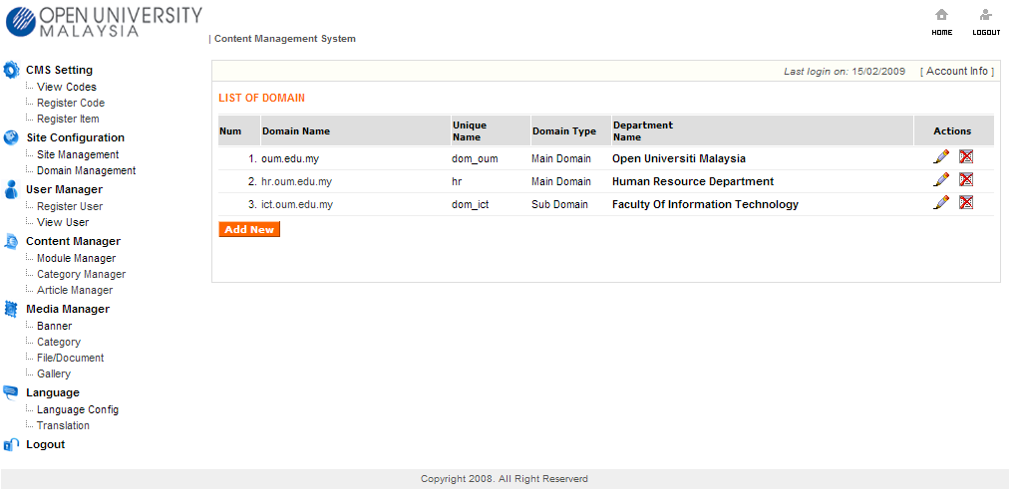

- User can add a new Main Domain or Sub Domain by clicking on the Add New button.

5.2.1. Editing domain properties

- Click the Edit button ( ) .
- Next, the interface will display the properties of the selected domain.
- To perform editing on the properties, click on Update.

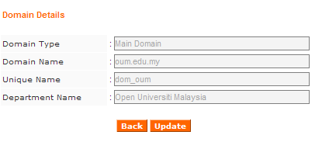

- The Domain Details now are ready to be updated. Take note that only Domain Root, Domain Name and Department Name are open for editing.

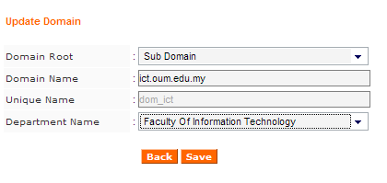

- After changes has been done, click on Save to store the changes.

5.2.2. Deleting a Domain

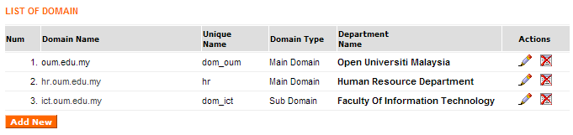

- Select a domain & click on Delete button ( ).
- User will be prompted with a confirmation window.

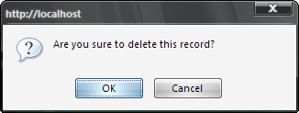

- Click OK to proceed with deleting the domain.
- The domain will be removed from the List of Domain.
- If there is any error encountered, the system will display a message as below and provide possible reasons.

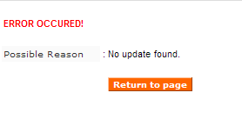

- Click on Return to Page button to revert back to the Update Domain page.
- Next, click OK on the prompt window to confirm that user is returning to the Update Domain page.

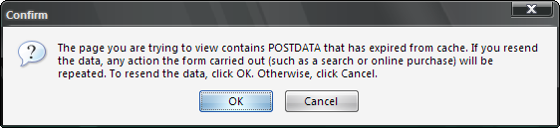

6. User Manager

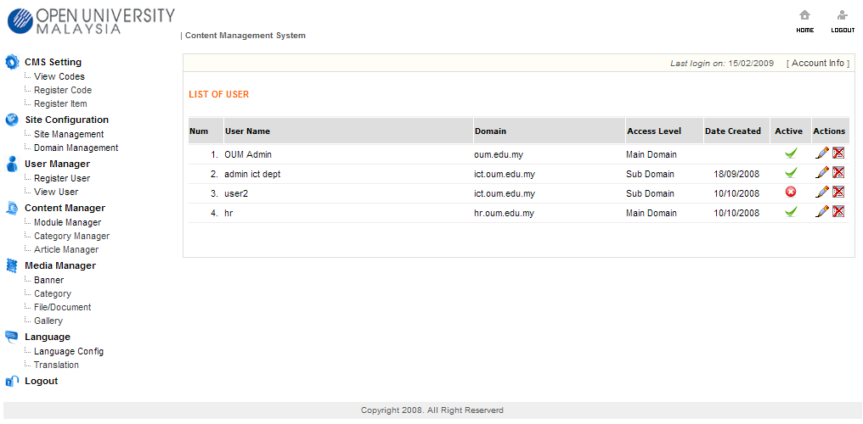

In this section, admin can perform new user registration. In addition, it also allows admin to monitor & view the list of current users registered in the system. The List of User is the default page if admin clicked User Manager shortcut from the CMS Administration page. Click the item under the section to perform admin operation.

Regarding User Status, the icon representation is as below:
- shows that the user status is activated in the portal.
- indicates that the user status has been disabled in the portal.
- click this button to edit the user details.

- click this button to delete the user from the list.

6.1. Register user

- To register a new user , click on Register User.
- The display area will show a User Registration form.
- Fill in the form accordingly with the particulars of the new user.
- Admin also must assign Login Name and an initial Password for the new user.

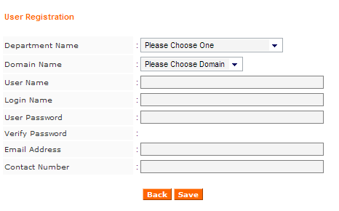

- Click Save to store the new user details in the system. Otherwise, click “back” to return to the previous display item.

6.2. View User

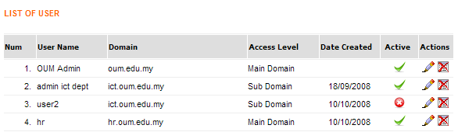

Regarding User Status from List of User, the indicator is as below:
- shows that the user status is activated in the portal.
- indicates that the user status has been disabled in the portal.
- click this button to edit the user details.

- click this button to delete the user from the list.

- From User Manager from the Menu Area, click on View User.
- The Display Area will show the list of users currently registered in the system. The user details shown are User Name, Domain, Access Level, Date Created (Registered), Active (Activated or Disabled) and Actions.
- To view a particular listed user, click on the Edit button. It will display the details of the user as entered by admin during registration.

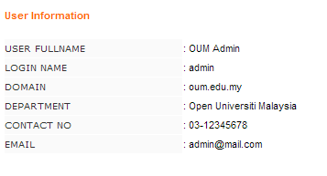

7. Content Manager

Under the Content Manager options, admin can manage items such as Modules, Category and Article.

7.1 Module Manager

Below are the content in the display area when admin clicked on Module Manager.

Module Manager
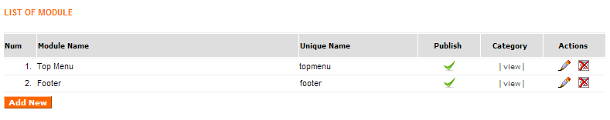

Regarding the Module Manager, the indicator is as below:
- shows that the module has been allowed to be published on the portal.
- indicates that the module has been disabled in the portal.
- click this button to edit the details of the selected module.

- click this button to delete the module from the list.

7.2. Category Manager

This section provides admin with the facility to customize the appearance of categories. Click on the Category Manager and the display area will show the Category View. From here, admin can set to publish or disable any selected category, edit the category, delete the category or to preview a selected article.

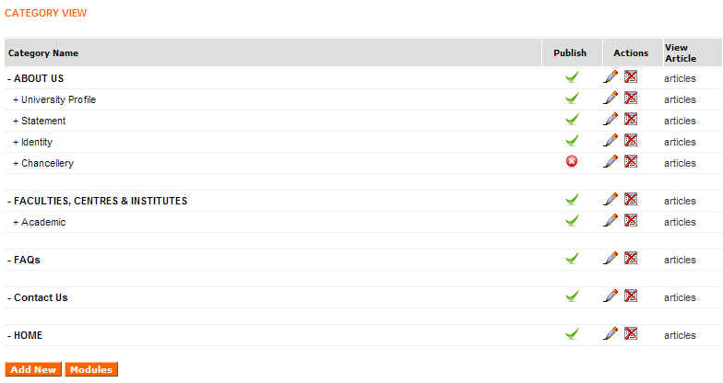

7.3. Article Manager

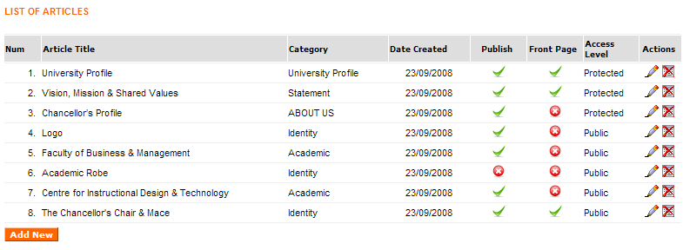

8. Media Manager

Media Manager is where admin will co-ordinate and administer the media files used in the portal. It consists of 4 different classifications as below:
i. Banner.
ii. Category.
iii. File/Document
iv. Gallery

8.1. Banner

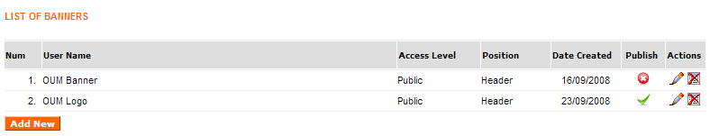

8.1.1. Adding New Banner

- From the List of Banners, click on Add New.
- The display area will show the Upload Banner form.
- Fill-in the respective fields with the new banner details.

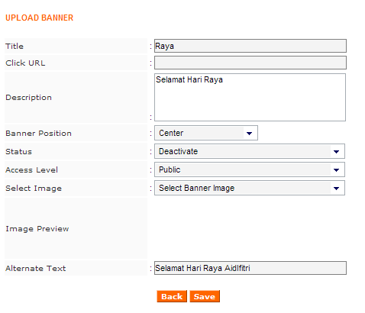

- Click Save to store the details of the new banner.
- The new banner will be listed in the List of Banners.

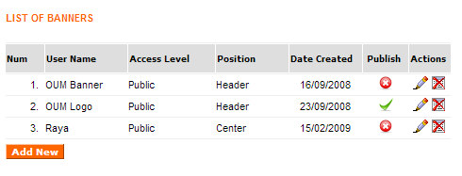

8.1.2. Editing Banner

- Click on the Edit icon on the Action column from List of Banners.
- The Edit Banner Information page will be shown on the Display Area.
- Update and make changes on the required field(s).

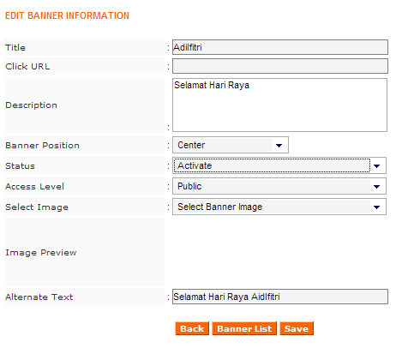

- Click on Save to store the changes made.
- The updated details will be reflected in the List of Banners.

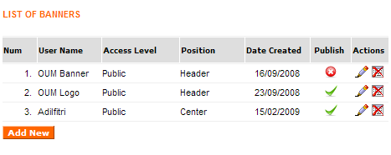

8.1.3. Deleting Banner

- To delete a banner, click on Delete icon on the Action column from List of Banners.
- A pop-up window will appear to prompt for confirmation on banner deletion.

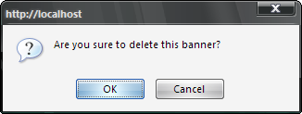

- Click OK to proceed with deletion of banner.
- The changes will be reflected in the List of Banners.

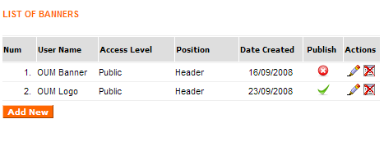

8.1.4. Activate/Deactivate Banner Publishing

- To activate or deactivate a banner, click on the icon under Publish column from the List of Banners.
- Set the status accordingly. For each click, the status of the language and the icon display will interchange between the 2 status as below:
- shows that the language has been activated in the portal.
- indicates that the language has been deactivated in the portal.

8.2. Category

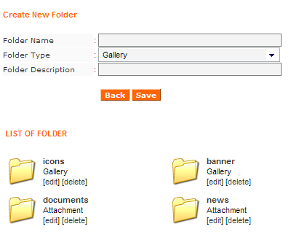

8.2.1. Adding New Category

- To add new folder category, fill in the details as required by the Create New Folder section.

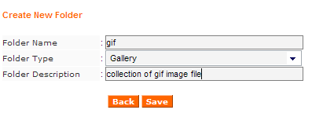

- Provide a name for the new folder in the Folder Name field.
- For Folder Type, admin have to define whether the new folder will be an item for Gallery or as Attachment.
- Provide a description to ease monitoring on the List of Folder section later.
- Click Save to create the new folder.
- The new folder will be shown in the List of Folder section.

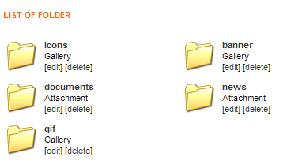

8.2.2. Editing Folders

- To edit the detail and properties of a particular folder, select the folder and click on [edit] text. This will open the Update Folder page.

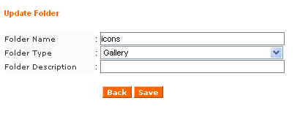

- Edit the details required such as Folder name, Type or Description.
- Click Save to store the changes.

8.2.3. Deleting Folders

- To delete a folder, click on the [delete] text, located next to the folder.
- A pop-up window will appear to prompt for confirmation of folder deletion.

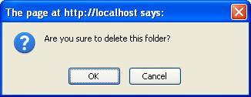

- Click OK and the selected folder will be removed.

8.3. File/Document

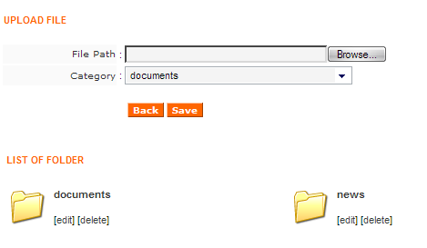

All the file or document being used in the portal will be monitored and managed under this section. The basic tools for files & documents are to upload file, assigned the location (category or folder) of the uploaded file, view the file and to delete them.

8.3.1. Adding New File/Document

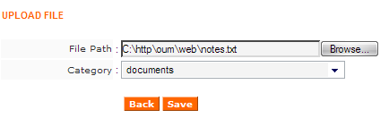

- From the Upload File section, for File Path, click the Browse button.

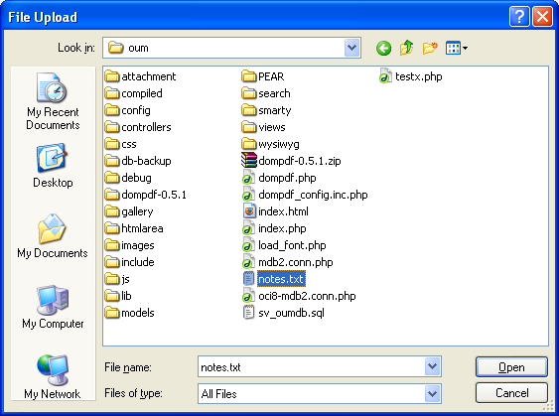

- Locate the file to be uploaded.
- Click Open.
- Next, select the category of the file to be uploaded.

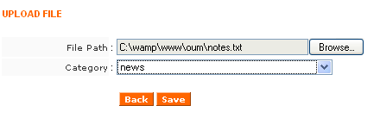

- Click Save and the file will be uploaded and stored in the respective category (folder). To view the document, click on the folder and the system will display the List of Files located in the folder.

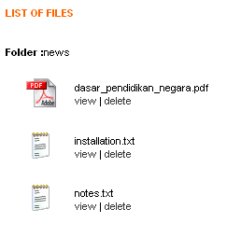

8.32. Viewing File/Document in folders

- From the List of Files, click on [view] text next to the document icon.
- The document will be displayed on a new window. Depending on the document format, it will automatically be opened using the respective application.

8.3.3. Deleting File Document from folders

- From the List of Files, click on [delete] text, situated next to the document icon.
- The document will be deleted from the folder.

Note: the document will be immediately deleted from the folder. There will be no pop-up window to prompt for confirmation.

8.4. Gallery

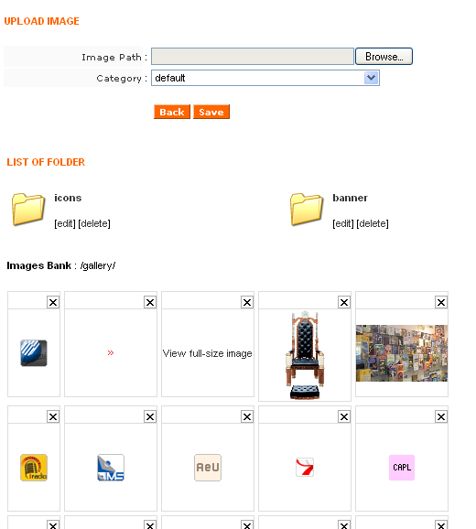

Gallery consists of 3 sections:

i. Upload Image - as a utility to upload image file to the selected folder(s).
ii. List of Folder - showing folders according to the category created.
iii. Images Bank - preview of items stored in the gallery folders.

This section is mainly an image management tool, where admin can easily manage and control the display of images that is being used in the portal.

8.4.1. Uploading Image

- To add an image to the gallery, use the Upload Image section.
- Point to the Image Path (file location) via Browse button.

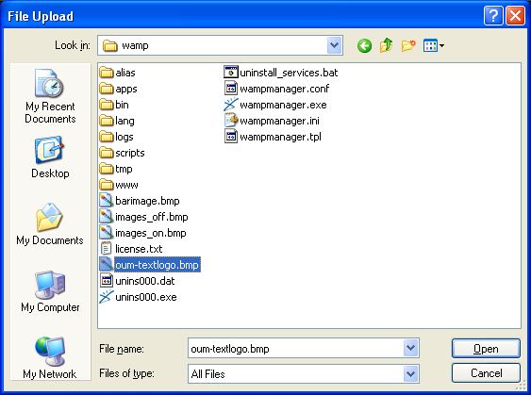

- Decide which folder (Category) will be used to store the uploaded image file. (select from the drop-down menu)

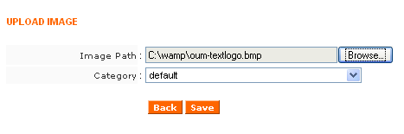

- Click Save and the image file will be stored in the selected folder.

- The image preview now can be seen on the Image Bank section. If necessary, scroll down the browser to find the uploaded image.

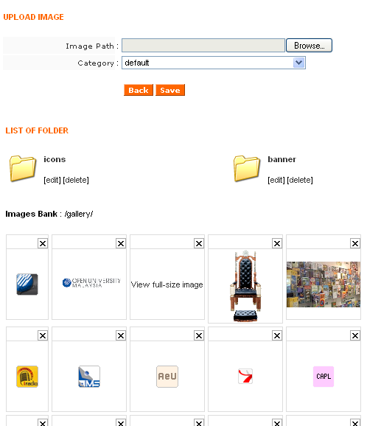

8.4.2. Editing Gallery folder

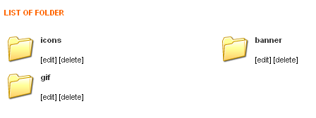

- To edit the Gallery folder, select a folder and click on the [edit] text.
- The display area will show the Update Folder page.
- Enter the updated details and any required changes.

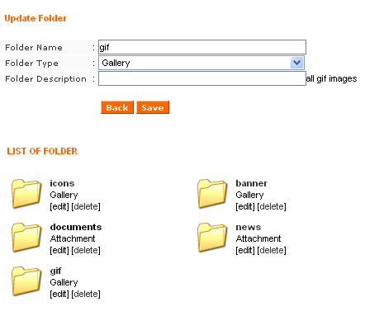

- Click Save to store the changes.

8.4.3. Deleting Gallery folder

- To delete a Gallery folder, select a folder and click on the [delete] text.
- A pop-up window will prompt for confirmation on folder deletion.
- Click OK to proceed.

- The folder will be removed from the List of Folder.

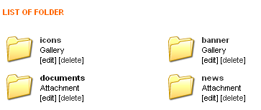

8.4.4. Image Preview

- To view all the images uploaded, click on Gallery and scroll the browser downwards.
- All of the uploaded images are displayed for preview at the Image Bank.

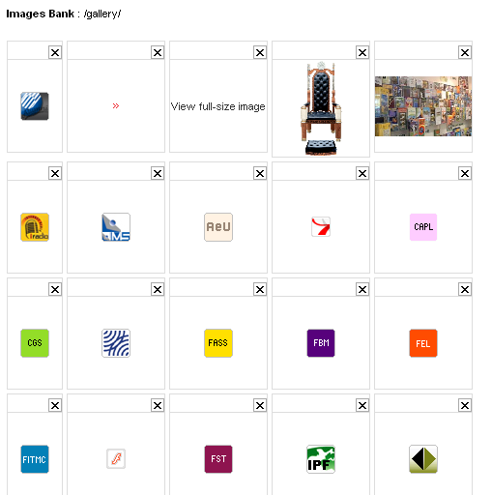

- To preview the image in its original size, click on the image. A pop-up window will show the image in its originally uploaded size.
- In addition, to delete any unwanted image, click on the checkbox () located on the top-right of each image box. This will immediately delete the image from the preview area and from the respective folder.

9. Language & Translation

9.1. Language Config

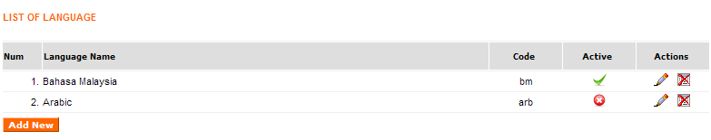

The Language Config displays list of additional languages for the portal. The default language for the portal is English. From here, admin can view the Language Name, Code for the language, Status of the language and Actions (Edit & Delete).

9.1.1. Adding New Language

- To add a new language, click on Add New.
- The display area will show Language Registration form.

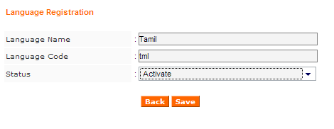

- Fill in the required details for the new language. (Name & Code)
- Set the language status, either Activate or Deactivate (select from drop-down menu).
- Click on Save to register the new language in the system. The language will be displayed in the List of Language.

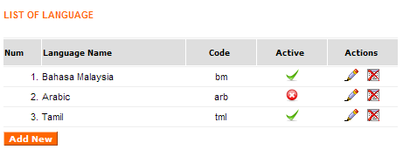

9.1.2. Editing Language

- Select a language and then click the Edit icon.
- The display area will show the selected language details, as what has been entered during language registration.

- Click on the field(s) to be edited and type in the new details.
- Set the status, either Activate or Deactivated (from drop-down menu).

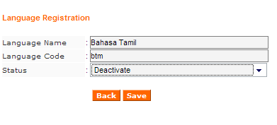

- Click on Save to store the changes made to the language details.
- The changes will be shown in the List of Language.

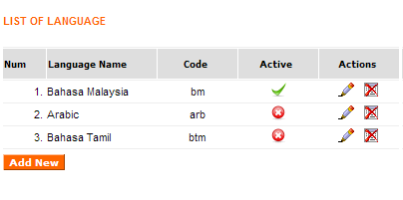

9.1.3. Deleting Language

- To delete a language, select the language and click on the Delete icon.
- A confirmation window will appear, requesting for confirmation on deletion of the selected language. Click OK to proceed.

- The language will be deleted and removed from the List of Language.
- To double-check, click on Language Config from the Menu Area and examine the List of Language.

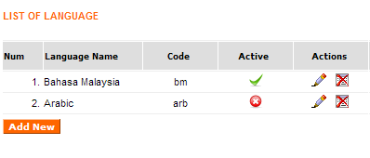

9.1.4. Activating/Disabling Language

- To activate or deactivate a language, click on the icon under Active column from the List of Language.
- Set the status accordingly. For each click, the status of the language and the icon display will interchange between the 2 status as below:
- shows that the language has been activated in the portal.
- indicates that the language has been deactivated in the portal.

9.2. Translation

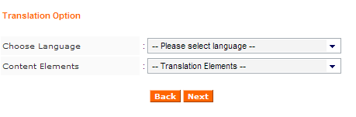

The Translation Option enable admin to choose the language to be used in the portal (Choose Language), while the Content Elements refers to the content which is the language will be applied to (e.g. either in Category or Content).

9.2.1. Translate Category

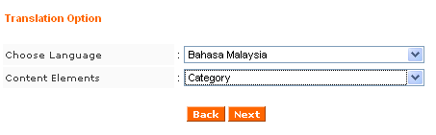

- Select the choice of language and choose Category from the drop down menu and click Next to proceed.
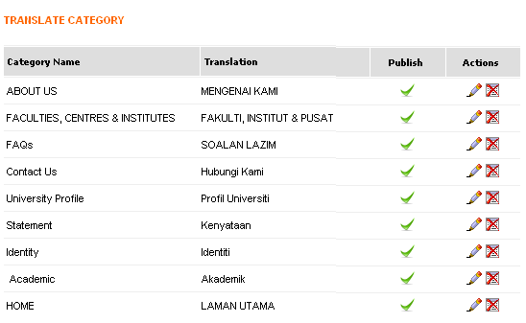

- The Translate Category 1st page will be displayed. From here, admin can select which category that requires translation by clicking the Edit icon.
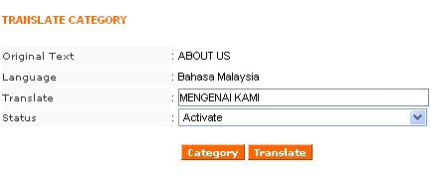

- The Translate Category 2nd page then will display a form to translate the category. Enter the translated details as required in the Translate field.
- Next, set the status of the translated category, either Activate or Deactivate. This setting is directly referring to the status of Publish/Unpublish in the Translate Category 1st page.
- Click Translate button to apply the changes.

9.2.2. Translate Content

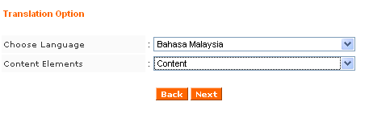

- Select the choice of language and choose Content from the drop down menu and click Next to proceed.
- The Translate Content 1st page will be displayed. From here, admin can select which content/article that requires translation by clicking the Edit icon ( ).

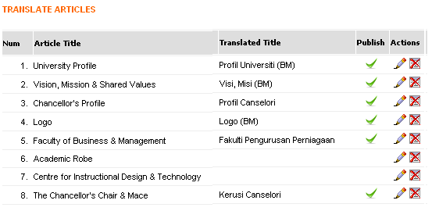

- Next, the Translate Article page will appear on the display area. From here, admin can type in the translated text in the Translate field (under Introduction & Full Content)

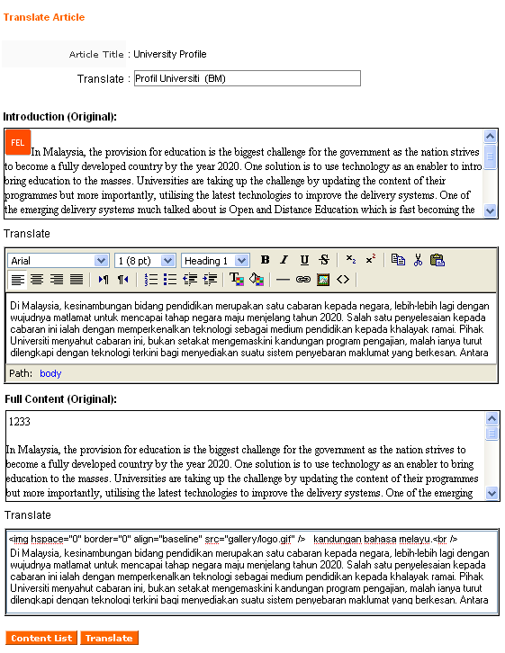

- After the content has been translated, click on the Translate button to store the content. Whenever the portal user change their language option, the portal will display the translated content, provided that the content has been translated and saved in this section..
- Next, click on the Content List button to return to the Translate Article page.

10. Logout

Clicking Logout will log admin out from the system. A pop-up window will alert its status with a confirmation that admin has been successfully logged out from the system.

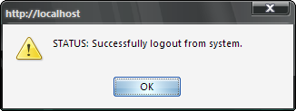

Click the OK button and system will return admin to the portal’s Login Page.

10.1. Auto Logout

For security reason, this system will automatically log the user out from the system if left idle for more than 10 minutes. After the period of time, if this window appeared, click OK and login again from the Login Page.

